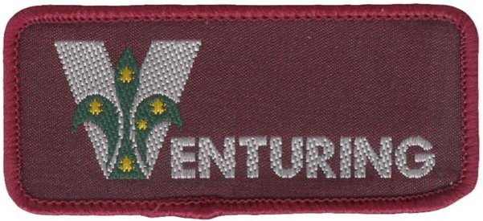
Venturing Skills Award
To qualify for the Venturing Skills Award, Venturer Scouts shall complete parts a, b, c and d:
a) First Aid
b) Bushwalking
Prior to participating in, and completing a two-day bushwalking expedition, demonstrate the following:
- The correct equipment to be taken and how it should be packed, including clothing, footwear, sleeping gear, food and water containers and wet and dry gear.
- How to pitch and strike a tent and fly. Explain factors in choosing a tent site, and the correct care of a tent, fly, poles and pegs during the journey and on return home.
- The planning of a menu, including quantities, for the expedition. Using lightweight hike cooking methods, cook a sustaining well balanced meal. Knowledge of minimal impact techniques including the correct method of rubbish disposal and camp hygiene.
- Knowledge of fire precautions and restrictions and the correct way to extinguish a fire. Demonstrate the correct use and care of a lightweight stove, and how to light a fire in adverse conditions.
- How to tie, and show the practical use of, four knots or rescue devices chosen by the Unit from the Unit's activities.
- How to read a map and orient it by both compass and visible features.
Be assessed in the above skills by the Expedition Leader.
c) Award Scheme
d) Unit Council
Scouts who have completed the Campcraft Target at Adventurer level may be considered for Recognition of Prior Learning

Develop a program based on part b) Bushwalking - it must cover at least one component of the highlighted section.

